**Validation Rules**

Validation Rules help maintain **data accuracy and integrity** by preventing users from saving incorrect or inconsistent data in records.

* A validation rule contains a **formula or expression** that evaluates one or more field values and returns **TRUE or FALSE**.
* If the result is **TRUE**, Salesforce **displays an error message** and prevents the record from being saved.
* If **FALSE**, the record is saved successfully.

⚠️**Limitations of Validation Rules**

* If multiple validation rules exist on the same object, you cannot control the order in which they fire.
* They run **only on insert and update**, not on delete.
* Too many complex validation rules can slow down record save performance.
* Maximum formula size is **3,900 characters** (compiled size up to **5,000 characters**).

**Formula Field**

A **Formula Field** is a **read-only field** that automatically derives its value based on a **formula expression** defined by the user.

* Formula Fields can be created on **both Standard and Custom Objects** and are evaluated **in real-time**.

**Return Types of Formula Fields**

|  |  |
| --- | --- |
| **Return Type** | **Description** |
| **Checkbox** | Returns TRUE or FALSE |
| **Currency** | Returns currency value and formats automatically |
| **Date** | Returns a date value |
| **Date/Time** | Returns date and time |
| **Number** | Returns numeric value |
| **Percent** | Returns percentage value |
| **Text** | Returns string or text value |

📝 **Note:**  
The **expression must return the same data type** as defined in the formula field.

**Types of Formula Fields**

**1. Simple Formula**

* Uses fields from the **same object** only.
* Example: AnnualRevenue / 12

**2. Advanced Formula**

* Uses fields from **related objects** via relationships.
* Includes **fields, operators, and functions**.
* Example: Account.AnnualRevenue * 0.1

**Operators Used in Formulas**

|  |  |
| --- | --- |
| **Type** | **Operators** |
| **Arithmetic** | +, -, *, / |
| **Relational** | <, >, <=, >=, =, <> |
| **Logical** | && (AND), ` |

**Common Formula Functions**

**Logical Functions (Boolean)**

* AND(), OR(), NOT()
* IF(), ISBLANK(), ISNEW(), ISNUMBER(), ISPICKVAL(), CONTAINS(), INCLUDES()

**Text Functions**

* LEN(), TRIM(), TEXT(), UPPER(), LOWER(), VALUE(),  
  LEFT(), RIGHT(), HYPERLINK(), SUBSTITUTE()

**Math Functions**

* ROUND(), CEILING(), FLOOR(), MAX(), MIN(), ABS()

**Date & Time Functions**

* TODAY(), NOW(), DAY(), MONTH(), YEAR(),  
  DATE(), DATEVALUE(), DATETIMEVALUE(), HOUR(), MINUTE(), SECOND(), WEEKDAY()

**Limitations of Formula Fields**

|  |  |
| --- | --- |
| **Limitation** | **Details** |
| **Character Limit** | Formula field can contain up to **3,900 characters** including spaces and comments. |
| **Save Size Limit** | Cannot exceed **4,000 bytes** when saved. |
| **Compile Size Limit** | Cannot exceed **5,000 bytes** after compilation. |
| **Field Restrictions** | Cannot reference **Long Text Area**, **Encrypted**, or **Description** fields. |

**Cross-Object Formula Field**

A **Cross-Object Formula Field** allows you to **reference and display data from a related parent object** in a child object record using a formula expression.

* Cross-object formulas **span across two or more related objects**.
* Supported for both **Master-Detail** and **Lookup** relationships.
* You can **navigate up to 10 relationship levels** in a single cross-object formula.

🚫 **Cannot be used:**

* To set **default field values**
* In **criteria-based sharing rules** or **roll-up summary filters**

**Roll-Up Summary Fields**

A **Roll-Up Summary Field** is a **read-only field** that automatically **calculates values from related child records** and displays the result on the **parent (master) record**.

* It is used to **summarize child data** (like totals, counts, minimum, or maximum values) in a **Master–Detail relationship**.
* Available **only on the master object** in a **Master–Detail relationship**.
* Once a roll-up summary field is created, the relationship **cannot be changed** from Master–Detail to Lookup.
* You can create a **maximum of 25 roll-up summary fields per object** (limit may vary by edition).

**Supported Roll-Up Summary Functions**

|  |  |  |
| --- | --- | --- |
| **Function** | **Description** | **Example** |
| **COUNT** | Counts the total number of related detail records. | Count how many Opportunities are related to an Account. |
| **SUM** | Calculates the total of numeric fields from related records. | Total Opportunity Amount for an Account. |
| **MIN** | Displays the smallest (minimum) value of a field in the related list. | Earliest Close Date among related Opportunities. |
| **MAX** | Displays the largest (maximum) value of a field in the related list. |  |

**Relationships in Salesforce**

**Lookup Relationship**

* **Loosely Coupled:** Child records exist independently of the parent.
* **Roll-Up Summary:** ❌ Not available.
* **Parent Record:** Not required when creating a child record.
* **Standard Object:** Can be on the *detail side* of a custom object.
* **Record Ownership:** Child record ownership is *independent* of the parent.
* **Cascade Delete:** ❌ Not supported — deleting the parent does not delete the child.
* **Limit:** Up to **40 Lookup relationships** per object.
* **Security:** No impact on parent-child sharing or access control.

**Lookup Options and Lookup Filter**

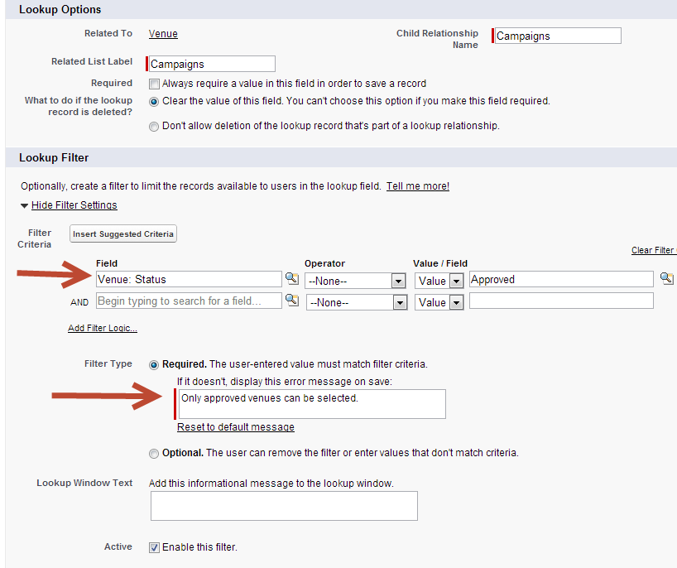

**Master-Detail Relationship**

* **Strongly Coupled:** The child (detail) cannot exist without its parent (master).
* **Roll-Up Summary:** ✅ Available — used to calculate SUM, MIN, MAX, COUNT on child records.
* **Parent Record:** Required when creating a detail record.
* **Standard Object:** Cannot be the child (detail) in the relationship.
* **Record Ownership:** Controlled by the parent. The *Owner* field is hidden on the child.
* **Sharing & Access:** Determined by the parent; manual sharing not allowed for detail records.
* **Cascade Delete:** ✅ Enabled — deleting the parent deletes all related child records.
* **Limit:** Maximum **2 Master-Detail relationships** per custom object.

**Master-Detail Options**

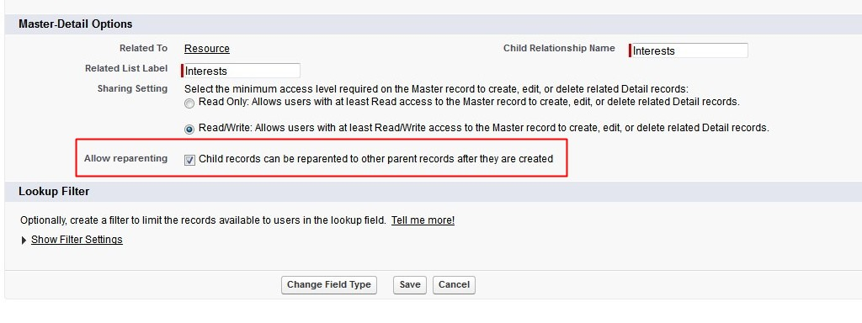

**Many-to-Many Relationship**

A **many-to-many relationship** allows each record in one object to be associated with multiple records from another object, and vice versa.

Salesforce does **not support many-to-many relationships directly** — you create them using a **Junction Object** that connects two Master-Detail relationships.

**Hierarchical Relationship**

A **special type of Lookup Relationship** available **only on the User object**. It allows a user record to reference another user.

Acts as a **self-relationship** (User ↔ User).

**External Objects**

**External Objects** are similar to custom objects but map to data stored **outside Salesforce** (e.g., in an external system or database).

* They allow Salesforce users to **view, search, and interact** with external data **in real time** using Salesforce Connect, without copying it into Salesforce.
* API name ends with **__x**.
* An **External Lookup Relationship** allows linking a **child standard, custom, or external object** with a **parent external object**.
* An **Indirect Lookup Relationship** allows linking a **child external object** with a **parent standard or custom object** inside Salesforce.

**External IDs**

An **External ID** is a custom field that stores a **unique identifier** for a record coming from an **external system** (e.g., ERP, SAP, or legacy database).

* Commonly used in **data import** and **integration** scenarios.
* ✅ Must be of type **Text**, **Number**, or **Email**.
* You can create up to **25 External ID fields per object**.
* External ID fields can be **unique** and **case-sensitive**.